**Firewall Configuration and Optimization Report**

**Prepared by: Kushagra Pandurang Pitre**

**Date: 22/07/2024**

**1. Introduction**

This report uses UFW (Uncomplicated Firewall) on Kali Linux to assess your current firewall infrastructure, identify potential vulnerabilities, and provide recommendations to optimize your configuration to improve your organization's overall network security posture.

**2. Current Firewall Infrastructure**

**2.1. UFW Overview**

UFW is an easy-to-use frontend for managing Iptables firewall rules on a Linux system. It simplifies firewall configuration and is commonly used on Debian-based systems, including Kali Linux.

**2.2. Current Configuration**

**3. Potential Vulnerabilities**

**3.1. Overly Permissive Rules**

* **Issue:** Rules allowing traffic on ports 22 (SSH), 80 (HTTP), and 443 (HTTPS) from any source.
* **Risk:** These rules could expose the system to unauthorized access and attacks.

**3.2. Logging Configuration**

* **Issue:** Logging is set to a low level.
* **Risk:** Important security events may not be logged, making it difficult to detect and respond to potential threats.

**3.3. Default Policy**

* **Issue:** The default outgoing policy is set to allow.
* **Risk:** Outbound traffic is not restricted, which could allow malware or unauthorized data exfiltration.

**4. Optimizing Firewall Configurations**

**4.1. Rule Optimization**

**Recommendation:**

* **Restrict SSH Access:**

Allow SSH access only from specific IP addresses or networks.

* **Restrict HTTP/HTTPS Access:**

Allow HTTP/HTTPS access only if necessary, and restrict to trusted sources where possible.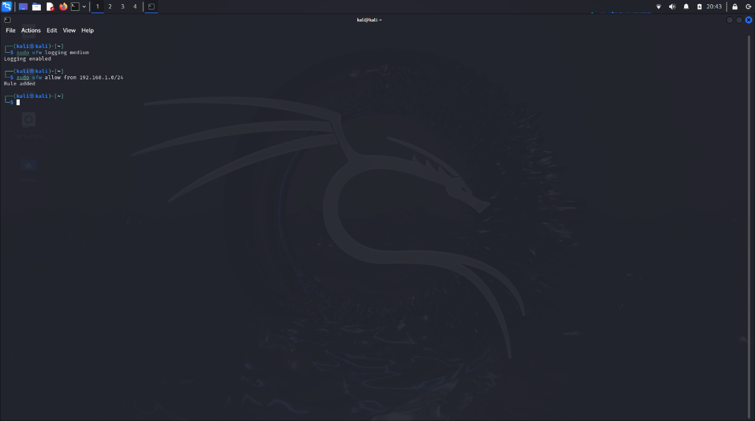

**4.2. Logging Configuration**

**Recommendation:**

* **Increase Logging Level**
* Set logging to a higher level to capture more detailed information.

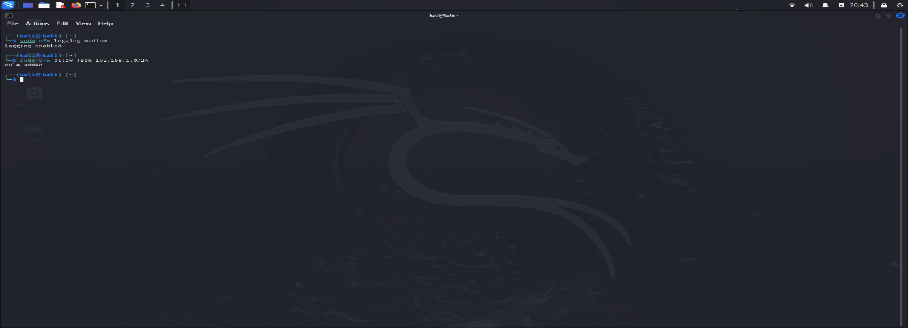**4.3. Default Policy**

**Recommendation:**

* **Restrict Outbound Traffic:**

Set default policy to deny outgoing traffic and create specific allow rules as needed.

**5. Continuous Improvement**

5.1. **Periodic Audits**

Conduct periodic audits: Schedule periodic reviews of firewall rules and configurations to maintain effectiveness and security.

5.2. **Monitoring and Alerting**

Enable Monitoring: Use monitoring tools to monitor fire activity and set alarms for suspicious activity.

5.3. **Personnel Train**  Personnel: Personnel must be regularly trained on the safety and importance of firefighting operations.

6. **Conclusion**

By solving identified problems and implementing recommendations, organizations can improve network security. Periodic screening, monitoring and training of personnel ensures that personnel are prepared to respond to future threats